FoodSafe



University of Umm Al-Qura
College of Computing
Department of Computer Science

Proposal by
Authors:

Supervisors
Dr. Ali Alzubaidi
aakzubaidi@uqu.edu.sa

Content
Chapter1: Introduction 2
1.1 Introduction 3
1.2 The research problem 3
1.3 The purose of the project 3
1.4 Purpose of this Document 5
1.4.1 Reason for Creation: 5
1.4.2 Contents: 5
1.4.3 Audience: 5
1.4.4 Usage: 6
1.5 Existing System 6
1.5.1 Cooltrax-cold chain management and control system 6
DicksonOne-cloud-based environmental monitoring system 1.5.2 7
1.5.3 TempTale GEO Ultra-cold 9
1.5.4 Sonicu-cold chain monitoring system 10
1.5.5 Shortcomings of the current systems versus the advantages of the proposed project 12
1.6 Methodology 13
1.6.1 Selected Methodology: Scrum (Agile) 13
1.6.2 Reasons for Selection 13
1.6.3 Objectives of Using Scrum 13
1.6.4 Comparison with Other Methodologies 14
1.6.5 Project Plan 14
1.6.6 Project Timeline Summary 17
1.6.7 Conclusion 17
1.7 Summery 18
SYSTEM ANALYSIS 19
Introduction 20
Functional Requirements 20
User Login (FR_001): 21
Function 2 (FR_002): 23
Function 3 (FR_003): 23
3. Dependencies 24
None- Functional Requirements 24
Security 24
Privacy 24
Ease of Use 24
Requirements Modelling UML 24
Use Case Diagram 24
Sequence Diagram 25
Activity Diagram 26
Class Diagram 26
Summary 26
DESIGN CONSIDERATIONS 27
Introduction 28
Architectural Strategy 28
Presentation Layer (User Interface Layer): 28
Business Logic Layer (Processing and Notifications): 28
Data Layer (Storage and Synchronization): 28
Development Requirements 29
Hardware Requirements 29
Software Requirements 29
Graphic User Interface Design and wireframe 29
Summary 30
CONCLUISON 31
Introdction 32
Challenges and learning experiences 32
Timeline 32
Furture work 32
Conclusion 32

List of figures

List ofTable
Table 1:Comparison with Other Methodologies 14
Table 2 Timeline & Weekly Activities: Phase 1 14
Table 3 Timeline & Weekly Activities: phase 2 15
Table 4 Project Timeline (Gantt style) 17

Abstract
Summary of the project

Chapter1: Introduction

1.1 Introduction
This project aims to develop a system based on the Internet of Things (IoT) to monitor and track food safety during transportation.
The system measures key factors such as temperature, humidity, and gas emissions inside the trucks, and then sends the data instantly to a simple platform or application to track it.
This project belongs to the field of Information Technology and the Internet of things with direct application in the food, transport and distribution sector.
The importance of the project lies in its role in ensuring the quality and safety of food, reducing spoilage and losses during transportation and storage, which supports food security and increases consumer confidence in food products.

1.2 The research problem
A Hungarian study published in the journal Foods in 2024 found that up to 30% to 50% of perishable food transported without proper temperature control can arrive at its destination spoiled or lost [1]. Upon further analysis of the underlying causes, one of the most critical issues identified in the food transportation chain is the failure to maintain proper temperature control, which significantly accelerates food spoilage.
Additionally, the lack of transparency in shipment tracking poses a major challenge, as many transportation systems lack accurate and real-time data regarding temperature and truck location. This makes it difficult to take timely action to prevent food deterioration.
Inspired by Islamic values that emphasize preserving blessings and valuing resources, this project aims to reduce food waste by designing a smart device equipped with sensors. This device is installed inside trucks to monitor temperature, humidity, and emitted gases, while also providing real-time tracking of location and internal conditions. The solution is intended to ensure better food preservation during transportation and reduce overall losses.

1.3 The purose of the project
1.3 Purpose of the Project
This project aims to develop a smart experimental system based on Internet of Things (IoT) technologies to monitor and track food safety during storage or transportation. The goal is to ensure food product quality, reduce the likelihood of spoilage, and support food security.
1.3.1 Main Objective of the Project
1.3.1.1 Develop a prototype that enables reading of basic data such as temperature, humidity, and gas emissions
• Temperature and humidity are among the most critical factors affecting food quality. According to the Food and Agriculture Organization (FAO), about 70% of refrigerated food spoilage is caused by uncontrolled fluctuations in temperature and humidity.
• The emission of gases such as ammonia (NH3) and hydrogen sulfide (H2S) serves as an early indicator of meat and dairy product spoilage.
• Therefore, this prototype provides a practical tool for accurately monitoring these indicators.
1.3.1.2 Transmit data in real-time to a simple platform or application for visualization
• Real-time monitoring reduces delays in problem detection.
• Studies in the field of cold chain monitoring show that delays in detecting temperature deviations may lead to losses of up to 35% of transported food products.
• Sending data directly to a platform or mobile application enhances responsiveness and immediate problem-solving.
1.3.1.3 Generate instant alerts when thresholds are exceeded
• Early alerts help in making timely decisions before losses occur.
• A study published in the Journal of Food Protection indicated that instant alert systems contributed to reducing refrigerated food losses by about 25%.
• This feature makes the system practical and economically valuable.
1.3.1.4 Test the system on a small-scale model to validate effectiveness
• Small-scale testing reduces risks and reveals errors before large-scale implementation.
• Prototypes are an essential step in developing any system, as they allow verification of hardware and software performance in a controlled environment.
• This increases the likelihood of success when scaling the project in the future.
1.3.2 Beneficiaries and Users
1.3.2.1 Food transport and distribution companies
• These companies face significant losses due to food spoilage during transportation.
• According to the World Bank, nearly 30% of food products worldwide are lost due to weak transport and storage systems.
• The proposed system helps these companies reduce losses through continuous monitoring.
1.3.2.2 Restaurants and food storage facilities
• Restaurants rely heavily on fresh ingredients, and their quality is directly tied to temperature and humidity conditions.
• Health reports indicate that one-third of food poisoning cases each year are linked to poor storage practices.
• By using the system, they can monitor inventory and protect customers from foodborne risks.
1.3.2.3 Regulatory authorities such as the Food and Drug Authority
• These authorities need accurate data to evaluate companies’ compliance with health standards.
• Traditional systems often rely on periodic manual inspections, while this system provides real-time and reliable data.
• This enhances regulatory efficiency and makes monitoring more proactive.
1.3.2.4 Consumers indirectly, by gaining access to safe products
• Consumers are the ultimate beneficiaries.
• The World Health Organization (WHO) reports that 600 million people fall ill every year due to contaminated food.
• Smart monitoring systems reduce the likelihood of unsafe products reaching consumers.
1.3.3 How the Project Helps Beneficiaries
1.3.3.1 Enable companies to monitor storage and transport conditions accurately and reduce losses
• The system provides companies with real-time intervention capability, which helps minimize financial losses caused by food spoilage.
1.3.3.2 Provide regulatory authorities with real-time and reliable data to support effective oversight
• Real-time data increases transparency and enhances authorities’ ability to make swift, informed decisions.
1.3.3.3 Enhance consumer confidence in the quality and safety of food products
• Smart monitoring systems build customer trust and provide companies with a competitive advantage in the market.
1.3.3.4 Support the community by reducing food waste and strengthening food security
• Reducing food waste directly contributes to global food security.
• According to the United Nations, about 14% of food is lost between harvest and retail, and this system can help reduce that percentage.

1.4 Purpose of this Document

1.4.1 Reason for Creation:
This document exists to outline the objectives, scope, and expected results of the smart food monitoring and tracking system project. It defines the purpose of the project and explains its importance in improving food quality, reducing waste, and supporting food safety.

1.4.2 Contents:
It contains details about the project goals, system functionalities, expected outcomes, and benefits. It also describes the technical and practical aspects of the prototype, as well as the target problems it aims to solve.

1.4.3 Audience:
The intended audience includes supervisors, academic instructors, project developers, stakeholders in the food supply chain, and regulatory authorities interested in food quality and safety.

1.4.4 Usage:
This document should be used as a reference throughout the project lifecycle. It guides the development process, supports evaluation and assessment, and provides a clear framework for understanding the project’s objectives, benefits, and applications.

1.5 Existing System
Currently, there are several systems and applications for monitoring food during transportation and storage, including intelligent refrigeration systems and heat and humidity sensors used in some major companies.

1.5.1 Cooltrax-cold chain management and control system

1.5.1.1 General description and mode of action
Cooltrax is an integrated system focused on monitoring refrigerated transport conditions and real-time Cold Chain Management. It offers a “Fresh InTransit " solution that allows monitoring trucks and refrigerated containers during their movement through wireless sensors connected to a communication module (Gateway) connected to a GPS tracking system. The system collects accurate temperature data inside the truck or container and sends it to the Cooltrax cloud servers. Users can follow the status of shipments moment by moment via a web dashboard or through phone applications. In addition, the system enables the creation of automated reports that support compliance with food safety standards such as HACCP and international regulations.

Figure 1

1.5.1.2 Basic techniques and components

1. Wireless temperature sensors are installed at various points inside the truck or refrigerated container.
2. GPS tracking modules to monitor the geographical location of the truck in conjunction with environmental data.
3. A cloud platform (Cooltrax Cloud) for receiving, analyzing and storing data.
A dashboard to provide a complete view of the transport situation in real time. 4.
5. Mobile apps for accessing alerts and data while on the move.
6. The possibility of integration with ERP systems or other logistics systems to provide more comprehensive cold chain management.

1.5.1.3 Common areas of use
Cooltrax is widely used in transport and logistics companies dealing with fresh food products, pharmaceutical companies, supermarket suppliers who need careful monitoring for long transport trips. It is also used in the import and export of sensitive materials such as meat, dairy products, and vaccines that require constant cooling.

1.5.1.4 Strengths
1. Integration of environmental monitoring with location tracking: the combination of geo-location data (GPS) and environmental shipment status enables accurate tracking and increases transparency.
2. Global real-time monitoring: the user can access the data of any shipment from anywhere via the internet.
3. Ready-made compliance reports: facilitates internal audits and organizational audits, saving companies a lot of time.
4. Instant alerts: if the temperature exceeds the permissible limits, instant notifications arrive for administrators.
5. Interoperability with other systems: flexibility in integration with ERP systems and transport management systems.
6. Increase customer confidence: by providing accurate data to customers about the status of their shipments.

Weaknesses 1.5.1.5
1. Greater focus on temperature: the system provides power in heat monitoring, but does not focus on additional elements such as moisture or gases (NH3, CO2, H2S) associated with food spoilage.
2. High initial cost: GPS + sensors + cloud subscription makes the system expensive, especially for small businesses.
3. Dependence on communication coverage: requires a strong and continuous cellular network or internet during transportation, a challenge in rural areas or international routes.
4. Operational complexity for small businesses: some advanced functions (such as ERP integration) may be redundant for small businesses, making the investment unfeasible.
5. High inflexibility in customization: companies may find it difficult to modify the characteristics of the system to suit specific needs.

1.5.1.6 Brief analysis
Cooltrax is one of the leading systems in the field of refrigerated transport monitoring and is characterized by combining temperature monitoring and geo-location tracking. This integration is very important for global supply chains and gives greater confidence to customers. However, its inability to monitor other environmental factors such as humidity and gases makes it limited when the goal is to detect early signs of spoilage inside the food itself. Also, its high cost makes it impractical for small and medium-sized businesses.

DicksonOne-cloud-based environmental monitoring system 1.5.2

General description and mode of action 1.5.2.1
DicksonOne is an integrated cloud-based system used to monitor environmental conditions (especially temperature and humidity) in sensitive environments such as hospitals, laboratories, food warehouses, and pharmaceutical industries. Based on data loggers connected to the internet via Wi-Fi or Ethernet, these devices continuously collect data and send it to a centralized cloud platform. Through this platform, users can view real-time readings, retrieve historical data, and adjust the settings of alerts and reports. The system also provides multi-user access, which allows administrative and technical teams to work simultaneously.
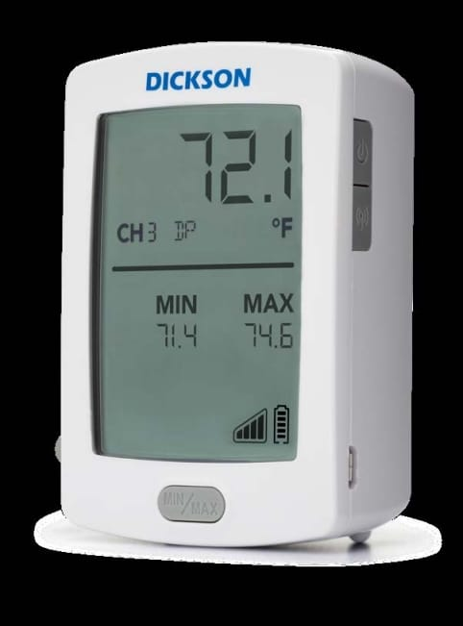
Figure 2

Basic techniques and components 1.5.2.2
Accurate temperature and humidity sensors connected to smart data recorders. 1.
Network connection (Wi-Fi / Ethernet) to send data to the cloud directly. 2.
3. A cloud platform (DicksonOne Cloud) for storing and analyzing data and providing ready-made reports.
An easy-to-use dashboard displays the status and location of each device. 4.
5. Multi-channel alerts (e-mail, text messages, alerts on the platform) in case of exceeding the permissible limits.
The possibility of integration with compliance and quality systems via exportable reports. 6.

Common areas of use 1.5.2.3
The system is widely used in hospitals and research centers that need careful monitoring of medical samples or medicines. It is also used in food warehouses and factories to ensure compliance with sanitary standards. Major pharmaceutical companies rely on it to comply with food and Drug Administration (FDA) standards and European safety regulations, because it provides reliable records that can be consulted upon review.

Strengths 1.5.2.4
Flexible cloud platform: allows data access from anywhere, anytime. 1.
2. Regulation-compliant automated reporting: helps medical and food institutions to easily meet compliance requirements.
Multi-channel alerts: increases the speed of response in the event of a malfunction. 3.
Scalability: a large number of devices can be added and linked to the same cloud account. 4.
Long-term data history: provides detailed records that help with later analysis. 5.
Simple user interface: makes it easier for non-technical teams to work with the system.

Weaknesses 1.5.2.5
1. Limited focus on heat and humidity: it does not provide monitoring for other indicators such as gases or air quality.
2. Ongoing cloud subscription fees: they can be a financial burden in the long run for some organizations.
3. Dependence on the network connection to the cloud: in the event of an internet outage, the data is not sent instantaneously (but remains saved locally and automatically synchronized later).
4. Limited flexibility in deep customization: the system is pre-designed for modular needs, and does not support substantial modifications to the architecture.
5. It requires simple preliminary preparation: especially in connecting devices to the network, but it is not complicated for those who have little experience in.

Brief analysis 1.5.2.6
DicksonOne is considered one of the globally reliable systems, especially in hospitals and laboratories, and provides great power in monitoring temperature and humidity. But its shortcoming lies in its dependence only on these traditional environmental factors. Ongoing subscription costs can also be a long-term burden for some organizations.

1.5.3 TempTale GEO Ultra-cold

General description and mode of action 1.5.3.1
TempTale GEO Ultra is an integrated real-time Cold Chain Monitoring and management system, widely used in the food and pharmaceutical industries. Developed by Sensitech, it combines advanced sensors, GPS tracking technology and a global network connection (GSM/4G LTE), allowing users to track their shipments during transportation anywhere in the world. The system works via smart data recorders placed with products inside trucks or refrigerated containers, these devices collect accurate data about temperature, humidity and geographical location, and then send it instantly to a centralized cloud platform. This platform enables users to track shipments moment by moment, and receive instant notifications in case of exceeding the allowed limits or any malfunction during the trip.
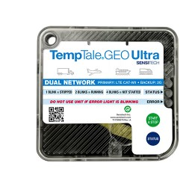
Figure 3

Basic techniques and components 1.5.3.2
1. Advanced data loggers (Data Loggers): measure temperature, humidity, and geographical location.
2. Built-in GPS technology: to accurately determine the location in real time.
3. Universal cellular connection (GSM/4G LTE): ensures data transmission from almost any network coverage area.
4. Centralized cloud platform (ColdStream Platform): receives and displays data via an easy-to-use interface.
Instant multi-channel alerts: via email, text messages, or platform notifications. 5.
6. Automatic reports: can be used to demonstrate compliance with standards such as FDA and GDP (Good Distribution Practice).

Common areas of use 1.5.3.3
TempTale GEO Ultra is mainly used in the transportation of heat-sensitive products, such as medicines, vaccines, and fresh food products. Major logistics companies rely on it to ensure the safety of their products during global distribution, especially when dealing with long distances or shipments need very precise conditions. It is also used in the agricultural and food industries to track products from farms to stores, enhancing transparency in the supply chain.

1.5.3.4 Strengths
1. Comprehensive real-time monitoring: combines temperature, humidity and location data, giving a complete view of the shipment.
2. Global tracking capability: thanks to cellular connectivity and GPS technology, cross-border shipments can be easily tracked.
3. Proactive alerts: helps users to intervene quickly in the event of a malfunction, minimizing losses.
Accurate compliance reports: facilitates the passage of audits from regulatory authorities. 4.
5. The possibility of managing several shipments at once: the cloud platform is designed to support large-scale operations.
6. Strong reputation in the market: being a product of Sensitech, a global company specializing in this field.

Weaknesses 1.5.3.5
1. High cost: devices are expensive and require annual or monthly subscriptions to the cloud platform.
2. High dependence on the cellular network: in areas where GSM/4G coverage is not available, data transmission may be delayed.
3. Complexity in initial operation: the user needs basic training to manage the system and take full advantage of its capabilities.
4. A basic focus on heat and humidity: although the system is accurate, it does not cover additional factors such as the emission of gases that may indicate the onset of food spoilage.
5. Hardware size: some sensor modules may be larger than required for small or sensitive shipments.

Brief analysis 1.5.3.6

TempTale GEO Ultra is one of the most powerful commercial systems in tracking refrigerated shipments globally, and is an ideal option for large companies with huge budgets and dealing with large-scale distribution. However, it mainly focuses on temperature, humidity and geographical location, and does not touch on other factors such as gases (NH3, CO2, H2S) that are an early indicator of food spoilage. In addition, the high cost makes this system unsuitable for small and medium-sized businesses. Here your proposed project has the advantage of being low-cost, more flexible, combining heat, humidity and gas monitoring with real-time notifications via a simple application, which makes it a practical and effective solution for a wider segment of users.

1.5.4 Sonicu-cold chain monitoring system

1.5.4.1 General description and mode of action
Sonicu offers a complete solution for monitoring sensitive environmental conditions (especially temperature and humidity) in real-time (real-time). The system installs wireless sensors inside warehouses, cold rooms, or pickup trucks; these sensors collect data such as temperature and humidity—and some specialized solutions monitor refrigerant or ammonia leaks—and then send it to a cloud platform called SoniCloud where it is displayed on a dashboard and accessible via a mobile app. At any deviation from the permissible values, the system issues multi-channel alarms (call, text message, email, push notification) with the feature of escalating the alarm (tired warning) to a higher destination if no action is taken.
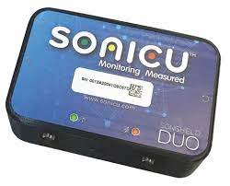
Figure 4

Basic techniques and components 1.5.4.2
1. Wireless temperature and humidity sensors, and some packages include refrigerant/ammonia leak sensors.
2. Connection modules (Gateways) support multiple networks: cellular, radio frequency, Wi-Fi, Ethernet.
3. A centralized cloud platform (SoniCloud) for data visualization, alarm management, and compliance records.
A mobile app for quick access and alerts. 4.
5. Support for backup batteries in some sensors to ensure continuous measurement during power outages.

1.5.4.3 Common areas of use
Sonicu is used in refrigerated warehouses, drug and vaccine storage rooms, hospitals (syringes and sensitive medical instruments), refrigerated transport vehicles that need constant follow-up during shipment. It is also used by food supply chains to meet compliance requirements (HACCP/FDA) and to reduce losses during distribution.

Strengths 1.5.4.4
1. Real-time and reliable monitoring: live data helps to take immediate action before products are damaged.
2. Multiple alerts and escalability: reduces response time and increases the effectiveness of fault handling.
3. Communication flexibility: cellular/Wi-Fi/radio support increases the operability inside and outside the trucks.
4. Automated compliance and documentation: creating reports ready for regulatory examination saves considerable time and effort.
5. Specialized solutions (coolant leaks/ammonia): useful for places that use industrial refrigerants and need monitoring of environmental safety.

Weaknesses 1.5.4.5
1. Initial and operational cost: advanced sensors + cloud subscription and technical support may make the solution expensive for SMEs.
2. Main focus on heat / humidity and refrigerant leaks: although there are ammonia/leak sensors, monitoring of food spoilage gases (such as H2S or advanced gas analyzes inside the shipment) is not always included in the basic or standard package.
3. Dependence on the communication infrastructure: in remote routes the quality of data transmission may be affected if cellular coverage is poor.
4. Customizability vs. vendor dependency: significant custom changes or custom features that may require special agreements and additional costs.
5. Maintenance and battery costs: sensors running on batteries may need periodic monitoring and replacement, especially in Long transport environments.

Brief analysis 1.5.4.6
Sonicu is a professional and proven product that covers the basic needs of cold chain monitoring and regulatory compliance, gives reliability and effective alerts that protect sensitive assets.

1.5.5 shortcomings of the current systems versus the advantages of the proposed project

1.5.5.1 cost factor
The problem: most of the current systems are expensive, both in terms of the price of devices and monthly subscription fees to cloud platforms, making them difficult to access for companies with limited budgets or in developing countries.
The solution in our project: providing a low-cost solution based on available commercial sensors and open source platforms, which reduces the overall cost and makes the system available to a wider segment of users.

1.5.5.2 comprehensiveness of follow-up
The problem: most systems are limited to monitoring only temperature and humidity, while some systems such as TempTale GEO Ultra add geo-tracking, which makes their ability to detect problems early limited.
The solution in our project: the system integrates a wide range of sensors that cover several basic aspects of cold chain monitoring, namely:

Sensitive to temperature and humidity: to strictly follow the storage and transportation conditions.
Door sensor: to detect any unauthorized opening of the door, which contributes to the Prevention of theft or the ingress of external pollutants such as dust or unclean air.
Geographic tracking (GPS): to track the location of the truck in real time and document its route.
Gas sensors (NH3, CO2, H2S): for early detection of food spoilage by monitoring the emission of biogas.
This integration makes the system more comprehensive and integrated compared to commercial systems, gives it a predictive and proactive ability to protect food products and ensure their safety during transportation and storage.

1.5.5.3 ease of Use and integration
Problem: many systems are oriented to large companies and require special training or technical experience for operation and management. Also, some of them mainly rely on email or periodic reports for alerting.
The solution in our project: to present a simple and easy-to-use application that works on smartphones or the web, with instant alerts sent via notifications, making the response faster and more practical.

1.5.5.5 contribute to food security and reduce losses
The problem: trading systems are often focused on achieving compliance and increasing the profits of large companies.
The solution in our project: focuses on serving the wider community by reducing food waste, enhancing food security, and increasing consumer confidence in products.

1.5.5.6 conclusion
It can be said that our project not only aims to imitate existing systems, but also seeks to fill their gaps by providing an integrated solution that combines: low cost, comprehensiveness of measurements (temperature, humidity, door, tracking, gases), ease of Use, and future flexibility, making it a more effective and sustainable option for different categories of users.

1.5.6 Comparison table between current systems and the proposed project

Ease of use | Weaknesses | Strengths | General description | System / project
Medium (requires technical experience and training) | 1.The cost of periodic subscriptions  2.Dependence on the internet connection  3.Limited customization | 1. Integration of environmental monitoring with geographic tracking.  2. Real-time global followup.  3.Instant alerts. | An integrated system for monitoring refrigerated transport conditions and real-time Cold Chain Management, based on wireless sensors + GPS + cloud platform. | Cooltrax
Relatively easy | 1.Ongoing subscription fees.  2.It depends on the network.  3.Limited in customization. | 1.Flexible and cloud platform.  2.Multi-channel alerts.  3.Long data history. | A cloud system for monitoring temperature and humidity via data Loggers connected to the Internet (Wi-Fi/Ethernet). | DicksonOne
Medium (requires preparation and training) | 1.Depends on cellular coverage.  2.He needs preliminary training.  3.The size of the devices is relatively large. | 1.Comprehensive monitoring (temperature, humidity, location).  2.Global tracking.  3.Manage several shipments together. | Real-time Cold Chain Monitoring and management system with GPS + GSM/4G LTE + cloud platform. | TempTale GEO Ultra
Medium (preparation and operation requires experience) | 1.High initial and operational cost.  2.Limited customization.  3.Cost of maintenance/batteries. | 1.Real-time and reliable monitoring.  2.Flexible connection (cellular/Wi-Fi/radio).  3.Specialized solutions for refrigeration/ammonia. | An integrated system for monitoring heat, humidity and some ammonia leaks via the SoniCloud cloud + mobile app. | Sonicu
Very high (simplified and easy-to-use application) | 1.A project is under development.  2.Need extensive field tests. | 1.Low cost.  2.Collects heat + moisture + gases (NH3, CO2, H2S) + the state of opening/closing doors.  3.Simplified and easy application. | A low-cost solution based on commercial sensors and open source platforms + an easy-to-use mobile/web application. | project
Observation:
It should be noted that the current comparison reflects the basic characteristics of the most common systems, however, some companies may introduce upgraded versions or models that include additional advantages such as wider measurements or advanced technical integrations. These versions are usually aimed at groups with special needs and come at a higher cost compared to the basic platforms.

1.6 Methodology
1.6.1 Selected Methodology: Scrum (Agile)
The project will adopt the Scrum (Agile) methodology, which is one of the most widely used iterative and incremental software development approaches. It emphasizes flexibility, continuous improvement, and delivering functional prototypes in short cycles (sprints).

1.6.2 Reasons for Selection
- Flexibility in dealing with hardware and software integration
  - The project combines sensors (hardware) with IoT platforms and a mobile/web application (software). Agile allows step-by-step testing of each component and smooth integration.
- Incremental delivery of a working prototype
  - The ability to test and validate a small-scale version before large-scale deployment reduces risks and ensures higher success.
- Rapid response to changes
  - Since the project may face unexpected issues (sensor calibration, connectivity problems, or application design adjustments), Agile allows continuous updates without disrupting the entire plan.
- Stakeholder engagement
  - Regular sprint reviews and demonstrations allow food industry stakeholders, supervisors, and academic instructors to provide feedback early.
- Support for future expansion
  - Agile makes it easier to integrate predictive analytics and AI in later phases without redesigning the entire system.

1.6.3 Objectives of Using Scrum
- To ensure that the system is developed iteratively, minimizing risks.
- To guarantee that user requirements (food companies, restaurants, regulators) are continuously considered and validated.
- To allow prototyping and testing of sensors, mobile application, and cloud integration at each sprint stage.
- To achieve a balance between time, cost, and quality while maintaining transparency and traceability of progress.

1.6.4 Comparison with Other Methodologies
Methodology | Strengths | Weaknesses | Suitability for This Project
Waterfall | Clear stages, structured, good for fixed requirements | Rigid, hard to adapt if requirements change, testing comes late | Not suitable because IoT projects need frequent testing and adjustments
Agile (Scrum) | Flexible, iterative, frequent feedback, supports hardware+software integration | Requires active collaboration and discipline | Most suitable because the project involves experimental prototypes, feedback, and gradual improvements
Table 1:Comparison with Other Methodologies

1.6.5 Project Plan
The FoodSafe project is aimed at developing an intelligent food safety monitoring system using IoT sensors, cloud integration, and mobile applications. The project will be executed over 10 months (40 weeks), divided into 20 sprints of 2 weeks each. Each sprint delivers a functional increment that can be tested and validated.
The plan is structured into six main phases, each addressing critical components of the system: hardware (sensors + Raspberry Pi), software (dashboard and mobile app), and cloud integration.
- Phase 1: Preparation & Setup (Sprint 1–2, Month 1)
Week | Dates | Activities | Objective / Deliverable
Week 2 | 31/08/2025 – 04/09/2025 | Team formation, brainstorm project ideas, initial supervisor meeting, assign roles | Organize team and define roles
Week 3 | 07/09/2025 – 11/09/2025 | Refine project idea, ensure feasibility, start progress tracking | Confirm feasibility and progress system setup
Week 4 | 14/09/2025 – 18/09/2025 | Finalize project idea and roles, draft initial project plan, get supervisor feedback | Approved initial project plan
Table 2 Timeline & Weekly Activities: Phase 1

Activities:
- Set up development environment (IDE, GitHub repository, Trello board).
- Install and configure databases (Firebase/MongoDB).
- Connect and calibrate temperature & humidity sensors using Raspberry Pi.
- Define system requirements and assign tasks to team members.
Deliverable:
- Initial development setup + working sensor prototype.
Raspberry Pi Role:
- Central controller for sensor data acquisition and initial processing.
- Chosen for low cost, ease of IoT integration, Python/Node.js support, and rapid prototyping.

- Phase 2: Basic Monitoring System (Sprint 3–6, Months 2–3)
Week | Dates | Activities | Deliverable
Week 5 | 21/09/2025 – 25/09/2025 | Define problem statement, objectives, outcomes, select development methodology, get supervisor feedback | Clear project scope and methodology
Week 6 | 28/09/2025 – 02/10/2025 | Literature review and project uniqueness analysis | Ensure originality and research grounding
Week 7 | 05/10/2025 – 09/10/2025 | Submit Chapter 1 draft; begin research and gather requirements (Chapter 2) | Chapter 1 submission & initial requirements collection
Week 8 | 12/10/2025 – 16/10/2025 | Continue research and gather requirements (Chapter 2) | Complete initial requirements collection
Table 3 Timeline & Weekly Activities: phase 2
Activities:
- Connect sensors to MQTT broker via Raspberry Pi.
- Develop a basic dashboard (Grafana/React) to display real-time temperature and humidity.
- Implement simple alert thresholds (email/console logs).
- Conduct initial testing with small data samples.
Deliverable:
- Dashboard prototype displaying live sensor data with basic alerting.
- Phase 3: Cloud Integration & Alerts (Sprint 7–10, Months 4–5)
Activities:
- Integrate system with cloud database (Firebase/AWS IoT).
- Develop real-time alerting system (SMS/push notifications).
- Improve dashboard with historical data tracking.
- Optimize sensor connectivity and reduce latency.
Deliverable:
- Cloud-connected monitoring system with instant alerts.

- Phase 4: Mobile Application Development (Sprint 11–14, Months 6–7)
Activities:
- Develop Flutter mobile app (Android/iOS).
- Connect app with cloud database for live updates.
- Implement alert notifications on mobile devices.
- Conduct usability testing with food transport staff.
Deliverable:
- Mobile app prototype with real-time data visualization and alerts.

- Phase 5: System Enhancement & Analytics (Sprint 15–18, Months 8–9)
Activities:
- Enhance dashboard visualization (graphs, charts, reports).
- Add multi-user access (admins, transport companies, regulators).
- Optimize system performance for reliability during long transport.
- Conduct integration testing (hardware + software).
Deliverable:
- Enhanced monitoring system with advanced analytics and role-based access.

- Phase 6: Testing, Security & Final Delivery (Sprint 19–20, Month 10)
Activities:
- Conduct load and stress testing for real transport scenarios.
- Implement data security measures (encryption, access control).
- Prepare documentation, user manual, and training guide.
- Deploy final system and present to stakeholders.
Deliverable:
- Fully tested, secured, and documented FoodSafe system ready for deployment.

1.6.6 Project Timeline Summary
Phase | Sprint(s) | Month | Deliverable
Preparation & Setup | 1–2 | 1 | Initial setup + sensor prototype
Basic Monitoring System | 3–6 | 2–3 | Dashboard prototype
Cloud Integration & Alerts | 7–10 | 4–5 | Cloud-connected system with alerts
Mobile App Development | 11–14 | 6–7 | Mobile app prototype
System Enhancement & Analytics | 15–18 | 8–9 | Enhanced monitoring system
Testing, Security & Final Delivery | 19–20 | 10 | Fully tested and deployed system
Table 4 Project Timeline (Gantt style)

1.6.7 Conclusion
In summary, this chapter has outlined a comprehensive and robust roadmap for the development of the FoodSafe project. The selection of the Scrum (Agile) methodology is a strategic decision, directly aligned with the project's inherent complexities involving hardware-software integration, evolving requirements, and the need for continuous stakeholder feedback. The detailed project plan, segmented into six distinct phases and twenty sprints, provides a clear, iterative, and manageable pathway from initial concept to final deployment. This structured yet flexible approach ensures that the project minimizes risks through incremental prototyping, validates functionality at every stage, and remains adaptable to changes and unforeseen challenges. By adhering to this plan, the project is well-positioned to deliver a fully tested, secure, and effective intelligent food safety monitoring system that meets its core objectives and provides a solid foundation for future enhancements.

1.7 Summery
In this chapter, the idea of the project, its goals and importance in monitoring food safety during transportation were presented, while clarifying the research problem related to the impact of food on environmental factors inside trucks. The purpose of the project and its detailed objectives were also determined, the beneficiary categories and the expected benefits of the system were reviewed. An overview of the current systems used in food control was also presented, with their advantages and disadvantages, and what distinguishes our project from them. Finally, the methodology followed in the development of the project and its implementation time plan were briefly presented.

SYSTEM ANALYSIS

Introduction
This chapter provides a comprehensive analysis of the system's functional and non-functional requirements. It outlines the features and functionalities of the application and presents the technical specifications needed for development

Functional Requirements
Functional requirements involves clearly describing what the system should do — the specific behaviors, features, and functions it must support. The following provide description the system functional requirments.
Example of writing the function based on software engineering formal writing

Example First you write the function name and give it and id
Function name (FR_001)
Provide a description of this function and then use this table to fill the information about this function
Field | What It Means | What to Include for Other Functions
ID | A unique identifier for the requirement | Use a consistent format like FR_002, FR_003, etc.
Title | A short, descriptive name of the function | E.g., "user log in", "Payment Processing", "Admin Dashboard"
Description | A brief explanation of what the function does | What the system should do and why it's important
Priority | Importance level (e.g., Must-Have, Should-Have, Nice-to-Have) | Helps prioritize development and testing
Actors | Who interacts with this function | E.g., User, Admin, System,
Inputs | What data or actions trigger the function | E.g., form fields, button clicks, uploaded files
Outputs | What the system returns or does in response | E.g., confirmation messages, redirection, data updates
Pre-conditions | What must be true before the function can happen | E.g., user must be registerd ,
Post-conditions | What should be true after the function is completed | E.g., logged in to main page
Flow | Step-by-step process of how the function works | Describe the user/system interaction in logical order
Acceptance Criteria | Conditions that must be met for the function to be considered successful | Use measurable, testable outcomes

Example

User Login (FR_001):
The User Login functionality allows registered users to access the platform securely using their email and password. This requirement supports session management, error handling for invalid credentials, and account security through lockout mechanisms. It is a core feature of the authentication module and integrates with user registration and password reset functionalities.

Table 5 Functional Requirement – User Login
Field | Details
ID | FR_001
Title | User Login
Description | The system shall allow registered users to log in using their email and password.
Priority | Must-Have
Actors | Registered User, System
Inputs | Email address, password, "Login" button click
Outputs | - Authenticated user is redirected to the dashboard  - Error message displayed for invalid credentials
Pre-conditions | - The user is registered with a valid email and password  - The system is online and accessible
Post-conditions | - Valid credentials: user is logged in and redirected  - Invalid credentials: error message shown  - Locked account: user is notified to contact support
Flow | 1. User navigates to login page  2. Enters email and password  3. Clicks "Login"  4. System validates credentials  5. Redirects or shows error message
Acceptance Criteria | - Valid credentials grant access within 2 seconds  - Invalid credentials show error without redirect  - 5 failed attempts lock account  - Failed attempts are logged  - Login page handles up to 5s latency

Example of writing the function using scenarios and userstory based on scurm methodology
Title: User Login
Actor: Registered User
Description:
Sarah, a Registered User, opens the platform to start her day. She quickly enters her email and password, and the system logs her in smoothly, showing her dashboard with upcoming tasks. One day, she mistypes her password and sees an error message, but after correcting it, she logs in successfully. After multiple failed attempts, her account locks temporarily, and she receives clear instructions to contact support. Throughout, Maria feels the process is fast, secure, and reliable.
User Stories for user login
- User Story (US_001): As a user, I want to log in with my email and password so that I can access my dashboard.
- User Story (US_002): As a user, I want to see an error message when I enter an incorrect password so that I know to try again.
- User Story (US_003): As a user, I want my account to lock after multiple failed login attempts so that my account is secure.
- User Story (US_004): As a user, I want the login page to remain responsive even with slow internet so that I can have a smooth experience.
Inputs:
- Email address
- Password
- "Login" button click
Outputs:
- Authenticated user is redirected to the dashboard
- Error message displayed for invalid credentials
- Lockout notification after multiple failed attempts
Pre-conditions:
- The user is registered with a valid email and password
- The system is online and accessible
Post-conditions:
- Valid credentials: User is logged in and redirected to the dashboard
- Invalid credentials: Error message is shown
- Locked account: User is notified and advised to contact support

Main Flow :
- User navigates to the login page
- User enters email and password
- User clicks the "Login" button
- System validates the credentials
- If valid, the user is redirected to the dashboard
Acceptance Criteria:
- Valid credentials grant access within 2 seconds
- Invalid credentials show an error without redirect
- 5 failed login attempts result in account lockout
- All failed attempts are logged
- Login page handles up to 5 seconds of latency gracefully

Function 2 (FR_002):

Table: Functional Requirement – Function 2
Field | Details
ID | FR_002
Title
Description
Priority
Actors
Inputs
Outputs
Pre-conditions
Post-conditions
Flow
Acceptance Criteria

Function 3 (FR_003):

Table: Functional Requirement – Function 3
Field | Details
ID | FR_003
Title
Description
Priority
Actors
Inputs
Outputs
Pre-conditions
Post-conditions
Flow
Acceptance Criteria

3. Dependencies
User Registration (FR_002): Users must be registered to have valid credentials.
Password Reset (FR_003): Users with locked accounts may need to reset their password.
Security Logging (FR_004): Failed login attempts are logged for monitoring

None- Functional Requirements
This section outlines the non-functional requirements that define the quality attributes of the system. These requirements ensure the system is secure, user-friendly, and compliant with modern web standards.

Security
NFR_001: The system must use SSL/TLS encryption to ensure secure data transmission between the client and server.
NFR_002: All passwords must be stored using secure hashing algorithms.
NFR_003: The system must implement account lockout after 5 consecutive failed login attempts to prevent brute-force attacks.

Privacy
NFR_004: The system must provide a clear and accessible privacy policy outlining how user data is collected, stored, and used.
NFR_005: Users must be able to view, update, or delete their personal data in compliance with data protection regulations .

Ease of Use
NFR_006: The application must have a responsive design that works seamlessly on desktops, tablets, and mobile devices.
NFR_007: The user interface must be intuitive and easy to navigate, with consistent layout and labeling.

Requirements Modelling UML
Unified Modelling Language (UML) is a standardized modelling language used in software engineering to visualize, specify, construct, and document the structure and behavior of software systems. UML diagrams help simplify complex system designs by providing a clear and structured representation of system components and their interactions. This section presents the key UML diagrams used to model the School System Login Module.

Use Case Diagram
The Use Case Diagram provides a high-level overview of the login functionality in the school system. Figure 1 shows interactions between actors such as Students, Teachers, and Administrators with the system. Key use cases include Login, Password Recovery, and View Dashboard.

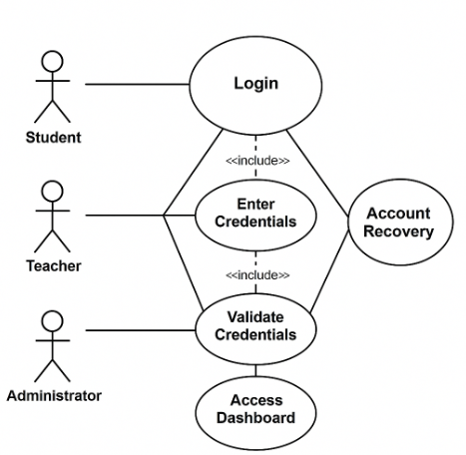
Figure 4– School System Login

Sequence Diagram
The Sequence Diagram illustrates the step-by-step interaction between a user and the system during the login process. Figure 2 shows how the user inputs credentials, how the system validates them, and what happens based on the result.
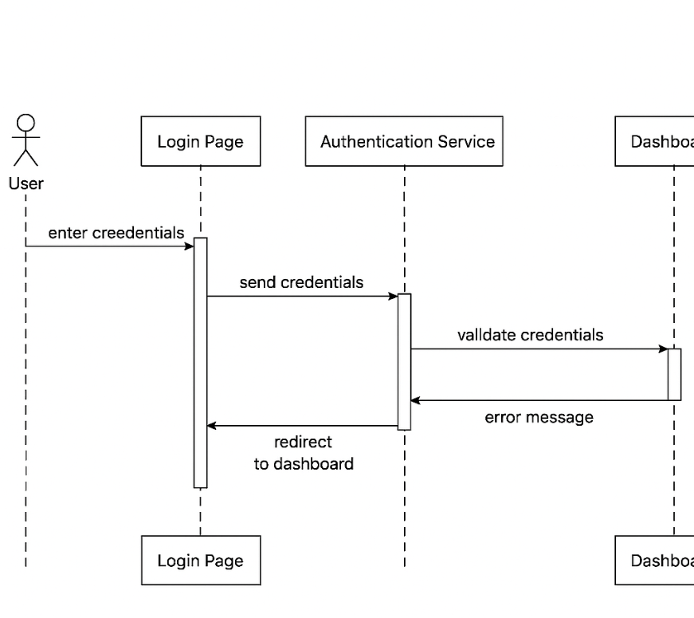
Figure 5 Sequence Diagram – User Login

Activity Diagram
The Activity Diagram represents the flow of actions during the login process. It includes steps like entering credentials, validation, success/failure paths, and redirection to the appropriate dashboard.

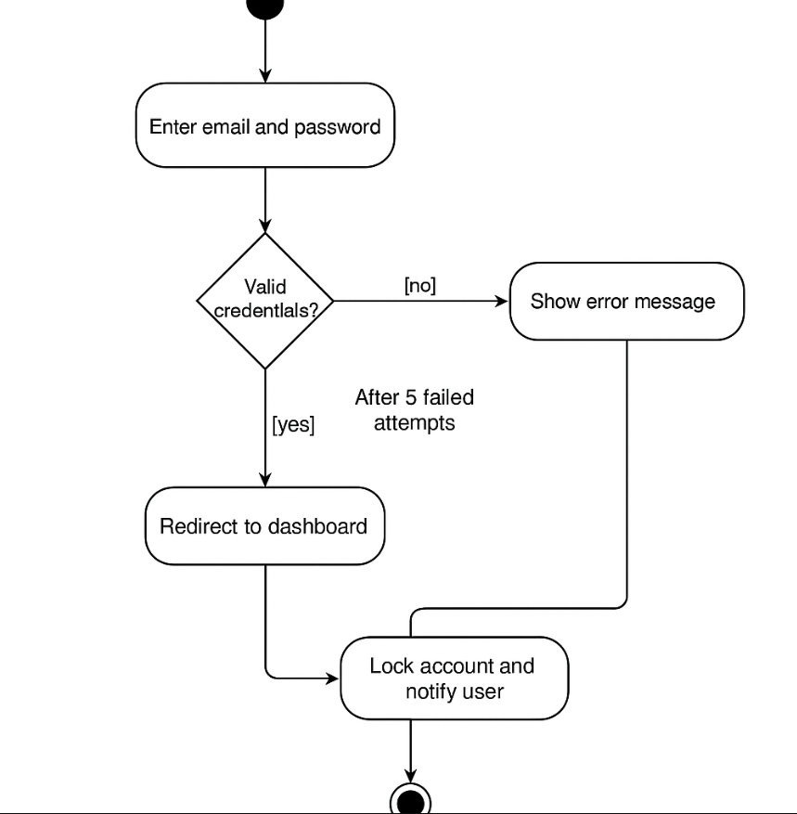
Figure 6 Activity Diagram – Login Process

Class Diagram

The Class Diagram shows the static structure of the login module. It includes classes such as User, LoginManager, and Session, along with their attributes and methods. Relationships between these classes are also illustrated.

Figure 4: Class Diagram – Login Module
(To be inserted: a diagram showing class names, attributes, methods, and associations)

Summary

DESIGN CONSIDERATIONS

Introduction
Design considerations include various elements such as functionality, usability, scalability, performance, maintainability, security, compatibility, and cost. we will create high-quality software that meets the needs of the users, while also meeting the requirements and specifications of the project.

Architectural Strategy
A well-defined architectural strategy is a foundational element of any software system. It encompasses the core components and services that collectively deliver the system’s functionality, performance, and user experience.In a typical application, when a user performs an action (e.g., submitting data), the system processes the input, stores it securely, and provides real-time feedback or updates based on predefined logic and rules. The architecture is commonly structured into three main layers which promotes scalability and maintainability.

Presentation Layer (User Interface Layer):
This is the front-facing part of the system where users interact with the application. It provides an intuitive and responsive interface for performing tasks such as data entry, navigation, and viewing reports or analytics.

Business Logic Layer (Processing and Notifications):
This layer handles the core logic of the application. It processes user inputs, enforces business rules, performs calculations, and triggers system responses such as alerts, validations, or automated actions. It ensures that the application behaves as expected under various conditions.

Data Layer (Storage and Synchronization):
This layer is responsible for storing and managing application data. It ensures data consistency, security, and availability across devices and sessions. It may involve cloud databases, local storage, or hybrid solutions, and supports real-time synchronization when needed.

Development Requirements

Hardware Requirements
Explain the hardware that you will use to develop the project
  - Computer/laptop for development (PC, Acer Laptop).
  - Stable internet connectivity.
  - Development server for testing.
  - Standard peripherals like keyboard, mouse, and monitor.
  - Backup solutions for data protection.

Software Requirements
To develop the system, the following software components are needed:
- Operating System: Windows 11
- A Server: A web server such as Apache or Nginx is required to manage the application content (XAMPP).
- Back-end development programing languages and frameworks: required for the system development- Backend.
- Lang1
- Lang2
- Lang3
- Frontend programing languages and frameworks: Required for the system development- Frontend
- Lang1
- Lang2
- Lang3

Graphic User Interface Design and wireframe
Show the UI interface design of the product. Also explain the wireframe is how the app or the site move from one page to another.
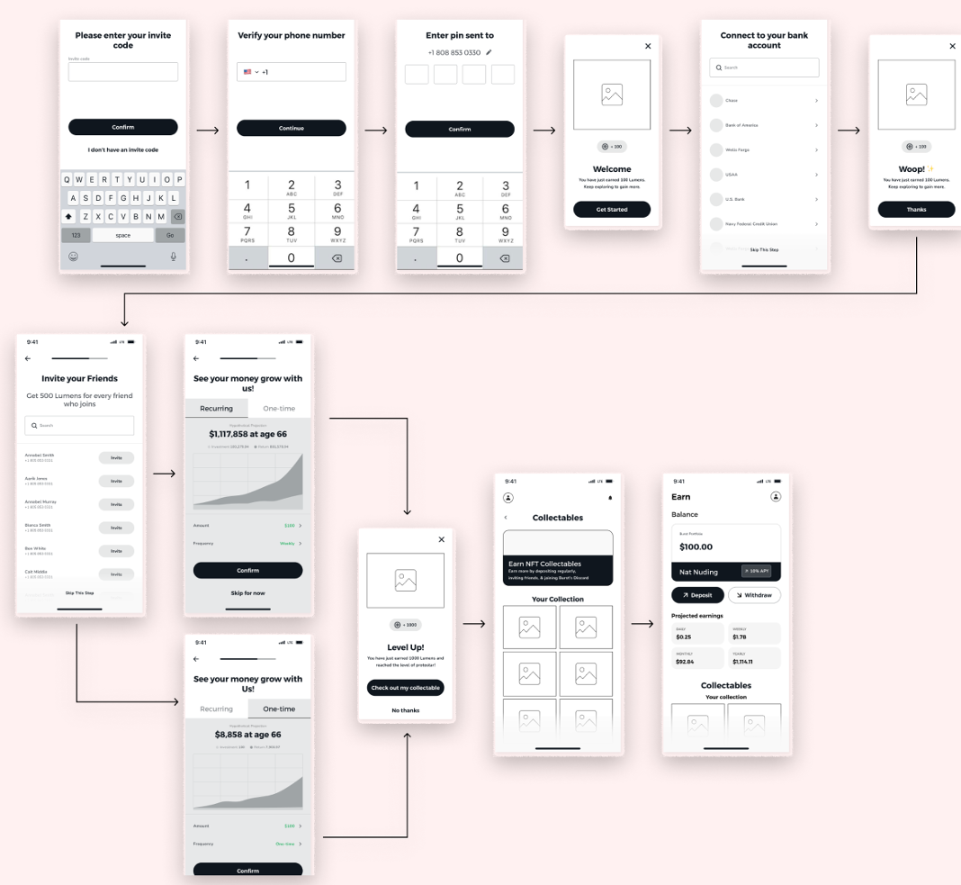

Figure 7 Example of product wireframe and UI

Summary
Summry of the chapter

CONCLUISON

Introdction

This chapter provides a comprehensive overview of our project, highlighting the challenges we encountered, the timeline of our work, and insights into future development. It concludes with a summary of the entire report.

Challenges and learning experiences
Expalin the challenges that your team faced during the project, and what have learnd form this project

Timeline
Illustrate the project time line

Furture work
Here your explain what will your team do In project 2

Conclusion
Provide a full summary of this project report

Reference:
[1] Eleonora Mercier, Stefanie Villeneuve, Mary Mondor, Ilker Uysal, Impact of Food Waste on Society, Specifically at Retail and Foodservice Levels, Foods, 2024.
[2] Food and Agriculture Organization of the United Nations (FAO). Food Loss and Waste Platform. Available at: https://www.fao.org/platform-food-loss-waste/en/

[3] Aung, M. M., & Chang, Y. S. (2014). Temperature management for the quality assurance of a perishable food supply chain. Food Control, 40, 198–207. https://doi.org/10.1016/j.foodcont.2013.11.016

[4] Liu, L., Chen, H., & Yang, H. (2019). Real-time monitoring system for cold chain logistics of perishable food based on wireless sensor networks. Journal of Food Protection, 82(4), 604–611. https://doi.org/10.4315/0362-028X.JFP-18-123

[5] World Bank. Food Loss and Waste. Available at: https://www.worldbank.org/en/topic/food-loss-and-waste

[6] World Health Organization (WHO). Food Safety Fact Sheet. Available at: https://www.who.int/news-room/fact-sheets/detail/food-safety

[7] United Nations. The Sustainable Development Goals Report 2019. Available at: https://unstats.un.org/sdgs/report/2019/
[8] Sensitech. (n.d.). TempTale GEO Ultra: Real-time temperature and location monitoring [PDF].
[9] Sensitech. (n.d.). Real-time temperature monitors. Retrieved from https://www.sensitech.com
[10] Maquimsa. (n.d.). DicksonOne data logger: Temperature, humidity, and differential pressure monitoring [PDF].
[11] Sonicu. (n.d.). Temperature monitoring systems. Retrieved from https://www.sonicu.com/temperature-monitoring
[12] Cooltrax. (n.d.). Cold chain monitoring solutions. Retrieved from https://cooltrax.com/
[13] Dickson. (n.d.). DicksonOne: Environmental monitoring solution. Retrieved from https://www.dicksonone.com/

